**Project Name: Fix Bugs Of The Applications**

**Developer Name: Kapil Davey**

**Project Description:**

We implemented one algorithm to fix the all kinds of bugs in applications, First we select the method called Optionselection.

On this method we perform the following operations:

1. I wish to review my expenditure.
2. I wish to add my expenditure.
3. I wish to delete my expenditure.
4. I wish to sort the expenditures.
5. I wish to search for a particular expenditure.
6. Close the application.

Manipulating the data by using the above operations to enhance the application & fix some sort of errors occurred at designed application.

**Algorithm:-**

**STEP 1:** Start

**STEP 2:** Import Arrays, ArrayList and Collections packages and instantiate the static main method

**STEP 3:** Call to the method optionsSelection() is made an array List of Strings which contains the list of options for the user to select

**STEP 4:** Another array of type int is created whose length is declared and all the elements int the String array are printed using a for loop

**STEP 5:** Array List of type integers are stored with expenses. And a desired option from the user is got to do the specified operation using scanner class.

**STEP 6:** A new ArrayList is instantiated and added to the expense array.

**STEP 7:** We fix the underlying problem that caused the bug.

**STEP 8:** The user selected option is put inside switch case and is matched with the correct case

**Step 9:** If the option does not match any of the statement default statement is printed

**STEP 10:** Stop

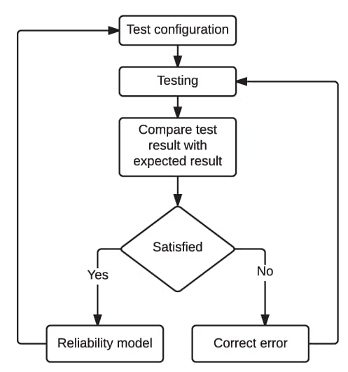**Flow of Fixing the errors in Application:**

C

**Conclusion:**  We designed a program to detect and fix the bugs by implementing the algorithms and testing and resolving the bug.

**GitHub Reciprocity Link**:- https://github.com/kapildavey/Phase1.git